**Practice of C-programming**

1. Write a program to print "Hello, World!" to the console.

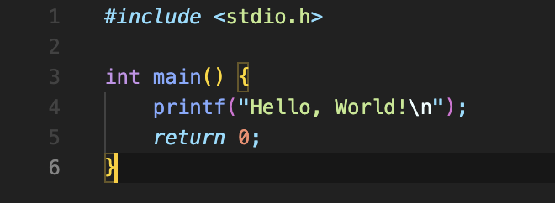

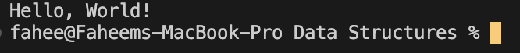

1. Write a program to find the sum of two numbers.

1. Write a program to swap two numbers without using a temporary variable.

1. Write a program to check if a given number is even or odd.

1. Write a program to find the factorial of a given number.

1. Write a program to generate the Fibonacci series up to a given number.

1. Write a program to check if a given number is prime.

1. Write a program to find the largest of three numbers.

1. Write a program to reverse a given string.

1. Write a program to find the length of a string without using the strlen function.



1. Write a program to check if a given string is a palindrome.

1. Write a program to count the number of vowels in a given string.

1. Write a program to sort an array of integers in ascending order.

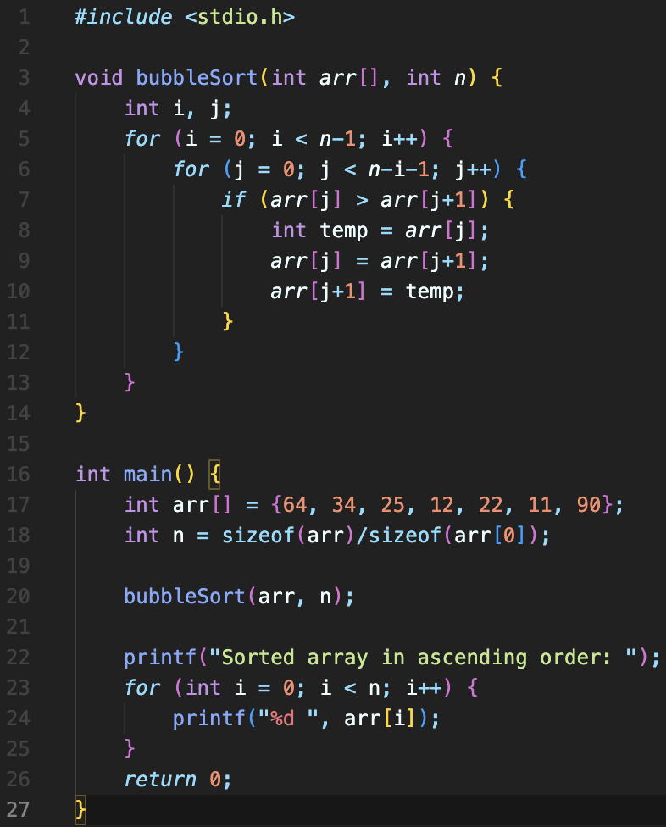



1. Write a program to search for an element in an array using linear search.

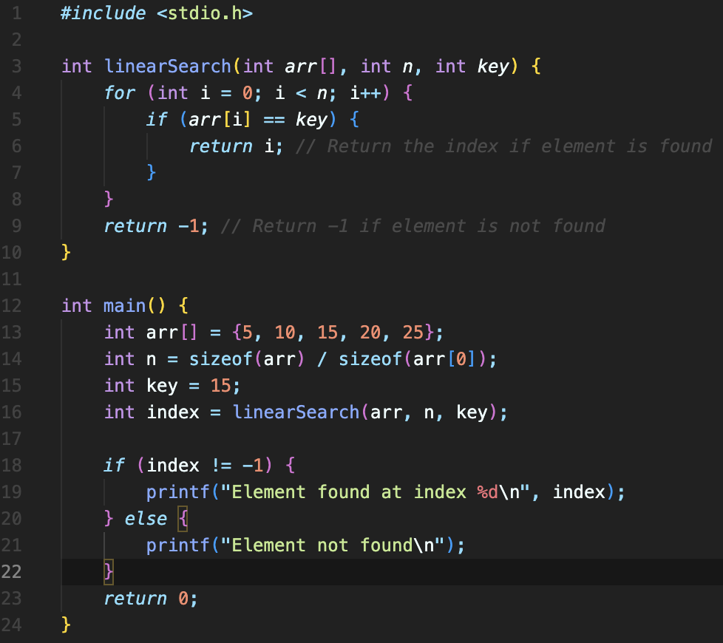

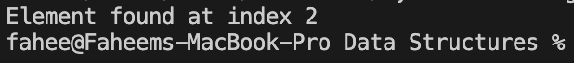

1. Write a program to search for an element in an array using binary search.



1. Write a program to merge two sorted arrays into a single sorted array.

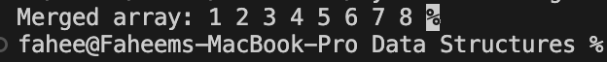

1. Write a program to find the second largest element in an array.

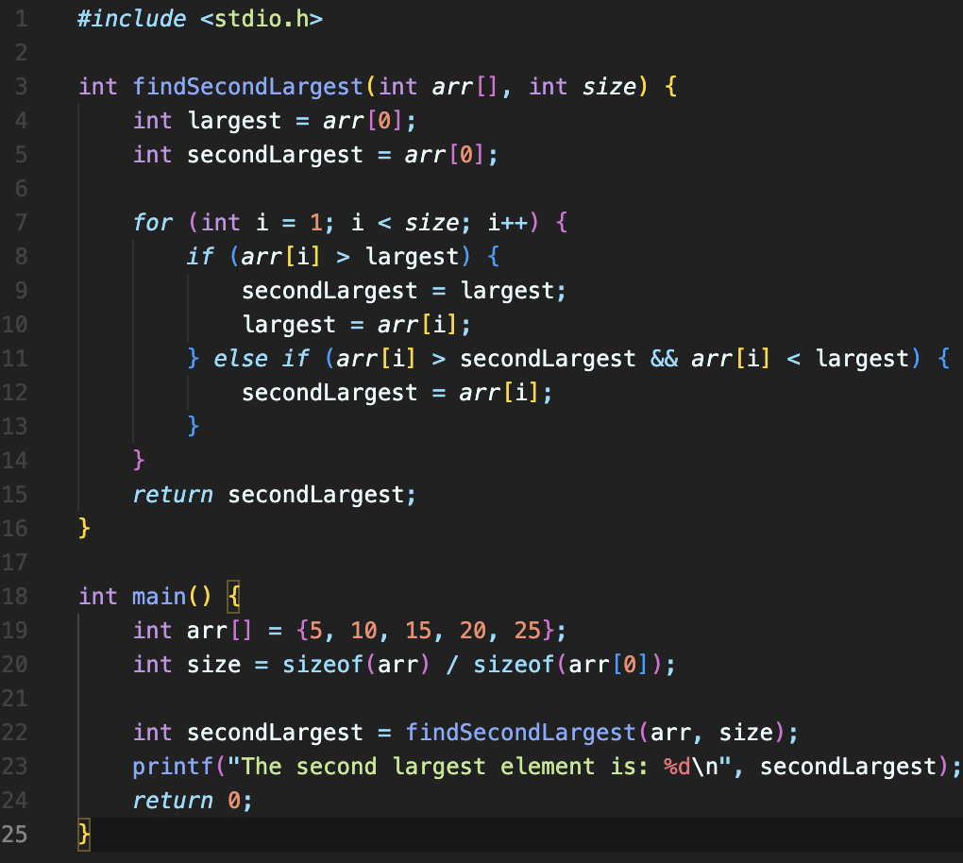

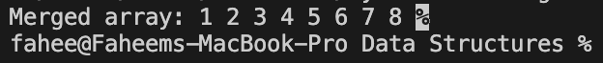

1. Write a program to count the number of occurrences of each character in a string.

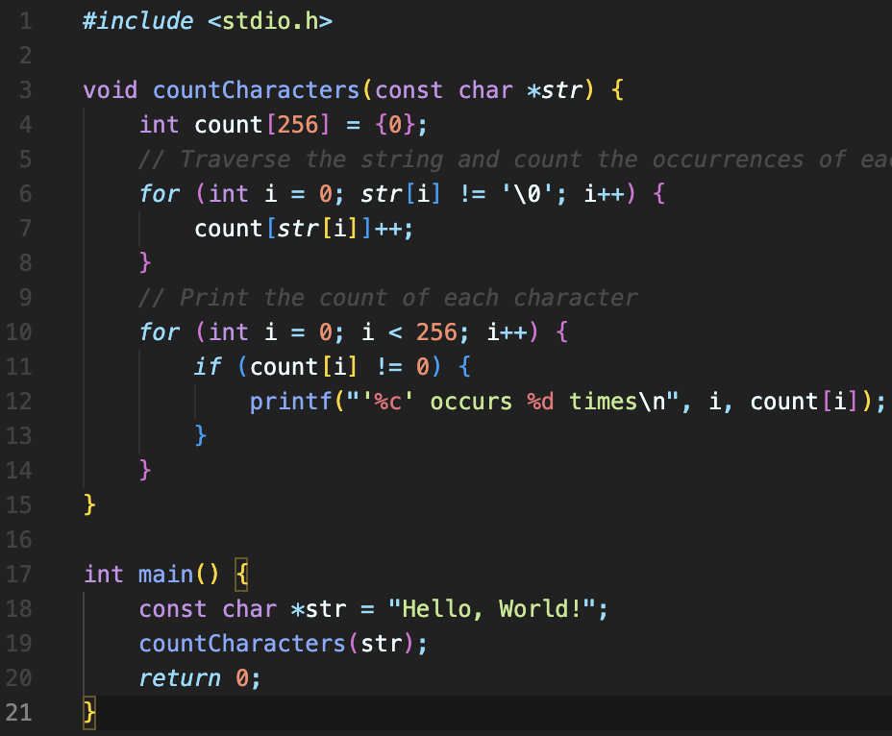

1. Write a program to find the GCD (Greatest Common Divisor) of two numbers.

1. Write a program to find the LCM (Least Common Multiple) of two numbers.

1. Write a program to implement matrix addition.

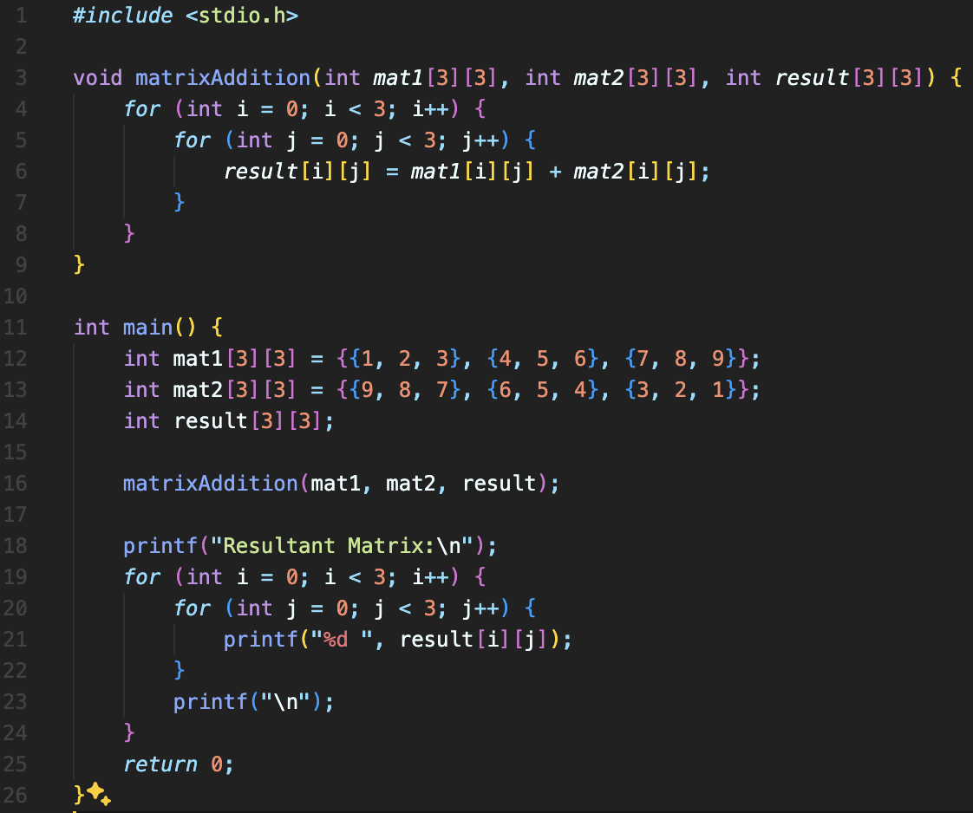

1. Write a program to implement matrix multiplication.

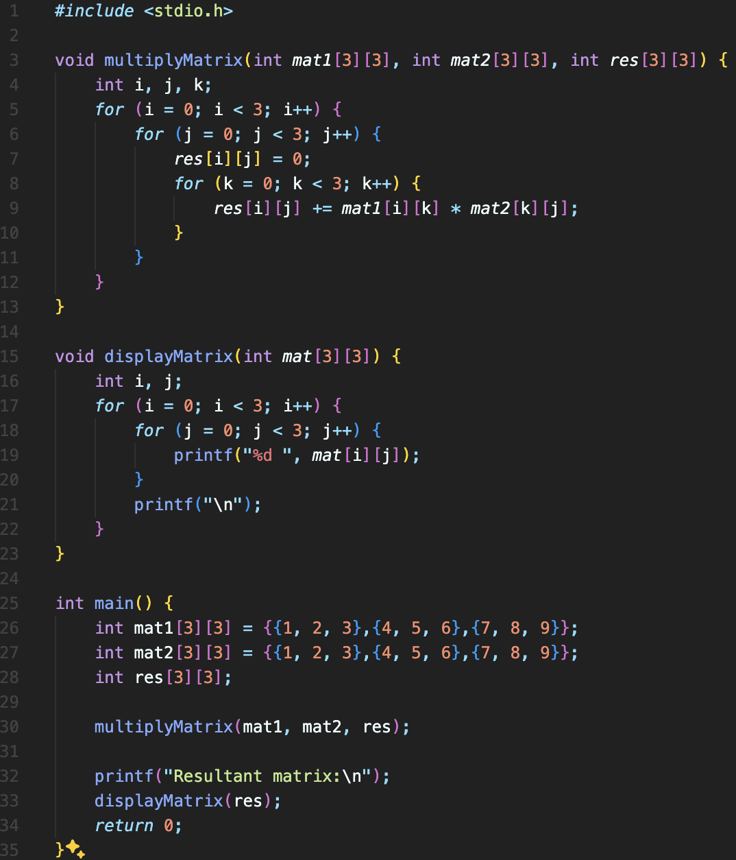

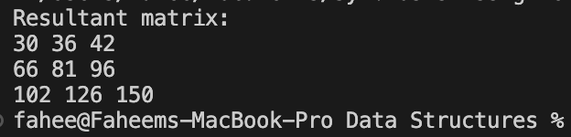

1. Write a program to find the transpose of a matrix.

1. Write a program to implement a simple calculator using switch case.

1. Write a program to convert a decimal number to its binary equivalent.

1. Write a program to convert a binary number to its decimal equivalent.

1. Write a program to find the sum of the digits of a given number.

1. Write a program to check if a given year is a leap year.

1. Write a program to print the prime numbers between 1 and 100.



1. Write a program to implement bubble sort.

